Ex 6. ESP32 exchange data using MQTT

Write a program for ESP32 to send and receive data via MQTT
Using wokwi https://wokwi.com/
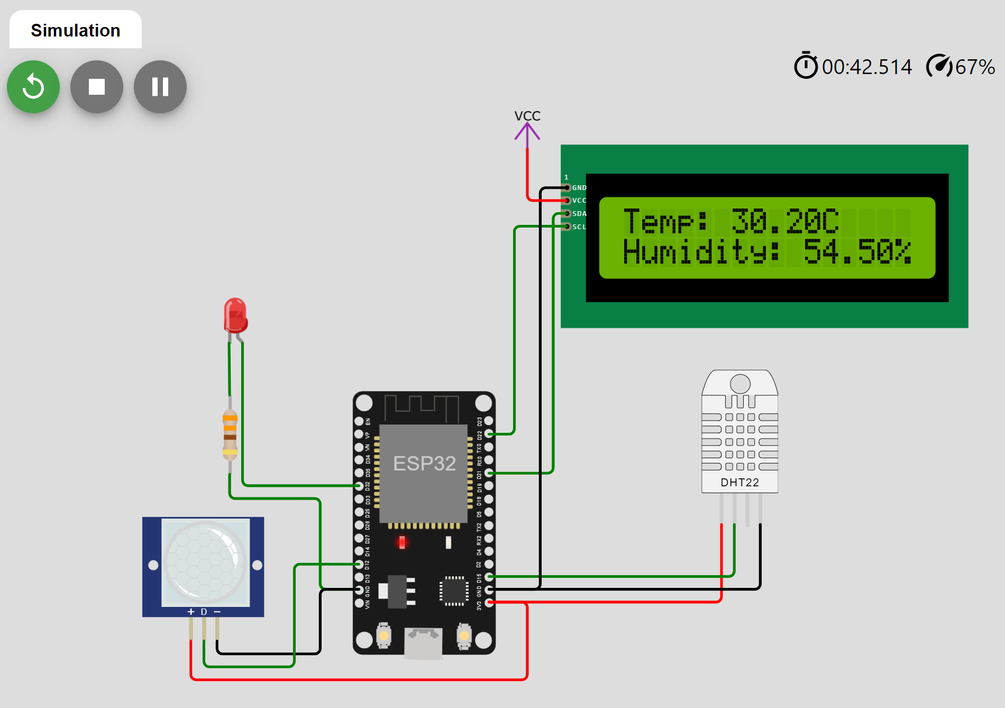
Requirement for the program:
a) Send the data collecting from sensors (temperature, humidity, PIR motion) via a MQTT broker.
b) Receive command data via MQTT broker, parsing the data by Json library and control LED on/off
The example of command data (json string)
{
"led1":0,
"led2":1,
"led3":1
}
0/1 => turn on/off the LED
MQTT broker example: broker.emqx.io
Submission:
Write a report with:
- The code and necessary explanation
- Link to wokwi simulation
- Some screenshots for demostration of program.
Submit the report
Reference:
https://github.com/knolleary/pubsubclient/blob/master/examples/mqtt_esp8266/mqtt_esp8266.ino

